COVID TEST and VACCINATION System

*User Guide*

|  |  |  |
| --- | --- | --- |
| **Supervisor.** | **Sir Khalid** | |
| **Batch.** | **2110B3** | |
| **Group.** | C | |
| **Serial No.** | **Enrollment Number** | **Student Name** |
| 1. | Student1342492 | AHMED ALI |
| 2. | Student1342494 | MUHAMMAD ASAD QURESHI |
| 3. | Student1342632 | ALI SHAHID |
| 4. | Student1336479 | MUHAMMAD RAMEEZ |

1. **Patient Login (login.php):**

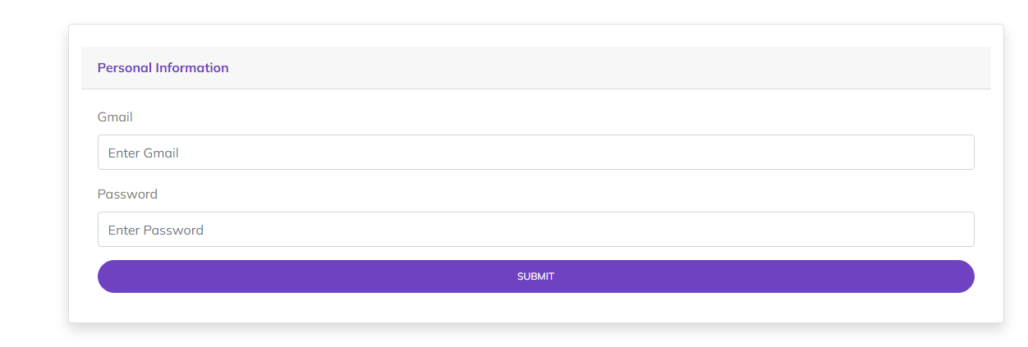

*Figure 1: Login page*

1. **Patient Signup (signup.php):**

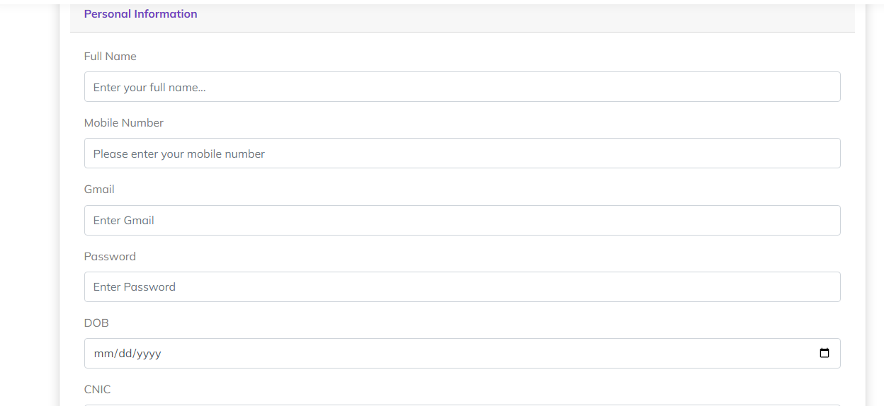

*Figure 2: Signup page* 

1. **Home (index.php):**

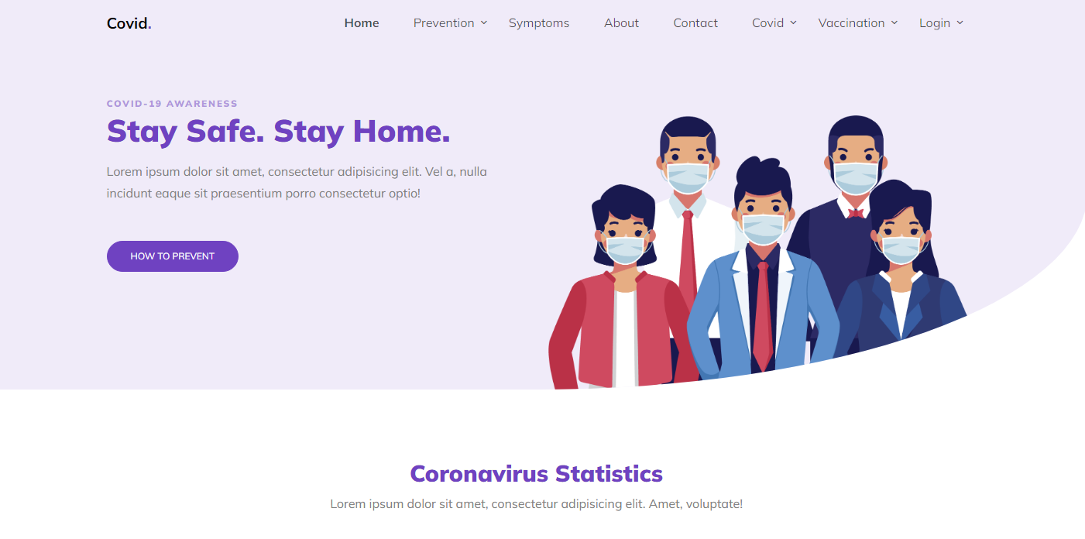

*Figure 3: Home page*

1. **Navbar (header.php):**



***Figure 4: Navbar***

We have given seven essentials. By clicking any of the essential’s and redirect to the linked page.

1. **About us (about.php)**

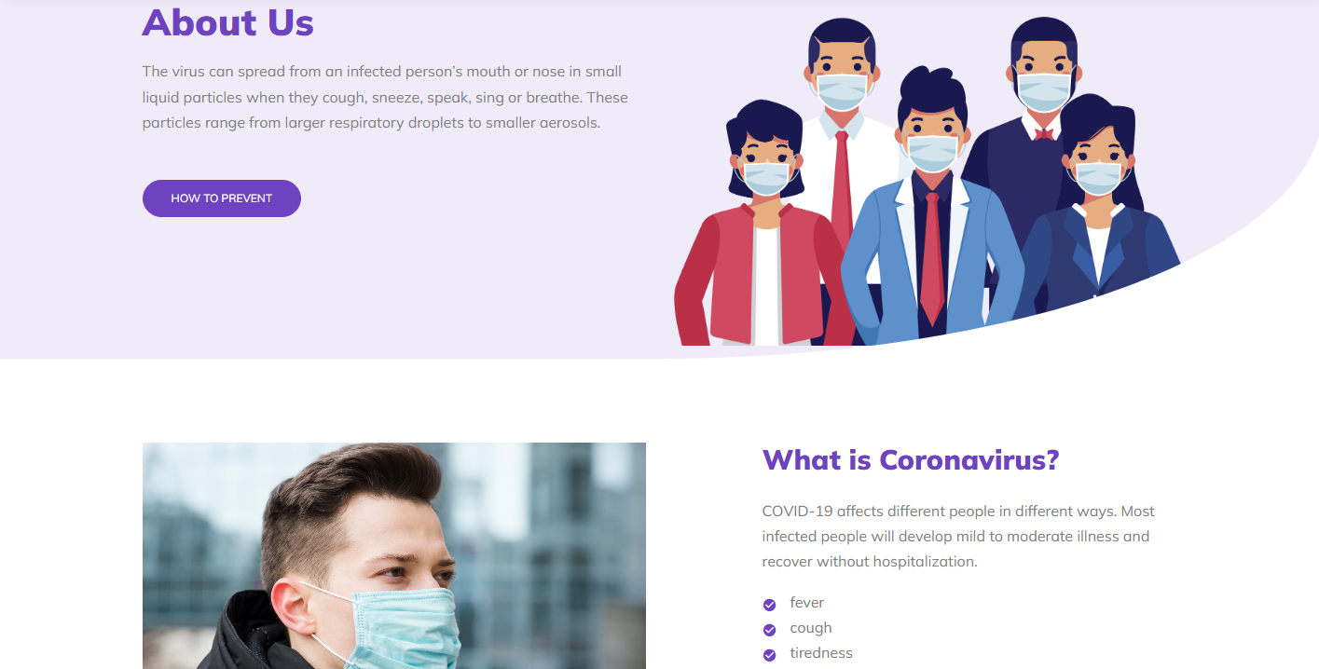

***Figure 5: About us***

**



** Explore different habitats, from the sweltering tropics to tidal rock pools.

** Discover all about our weird and wonderful creatures with fun and interactive learning experience.

**To be a destination of choice where all are welcome and motivated to join as a driving force for aquatic life.

1. **Covid Appointment (covidtest.php)**

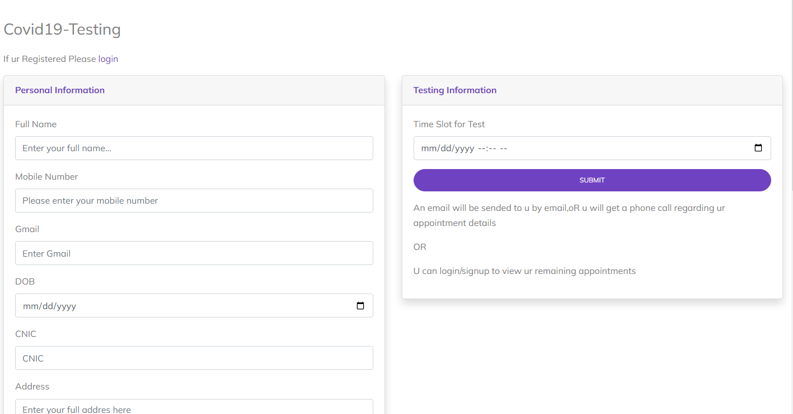

***Figure 6: Covid Test Appointment***

*We have mentioned our basic services to make people known about the service we provide.*

1. ***Search Reports(covidresult.php)***

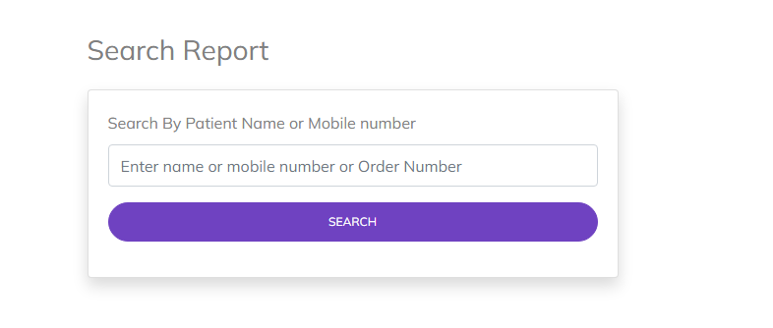

*Figure 7:Search Reports*

1. ***Contact Us(contact.php)***

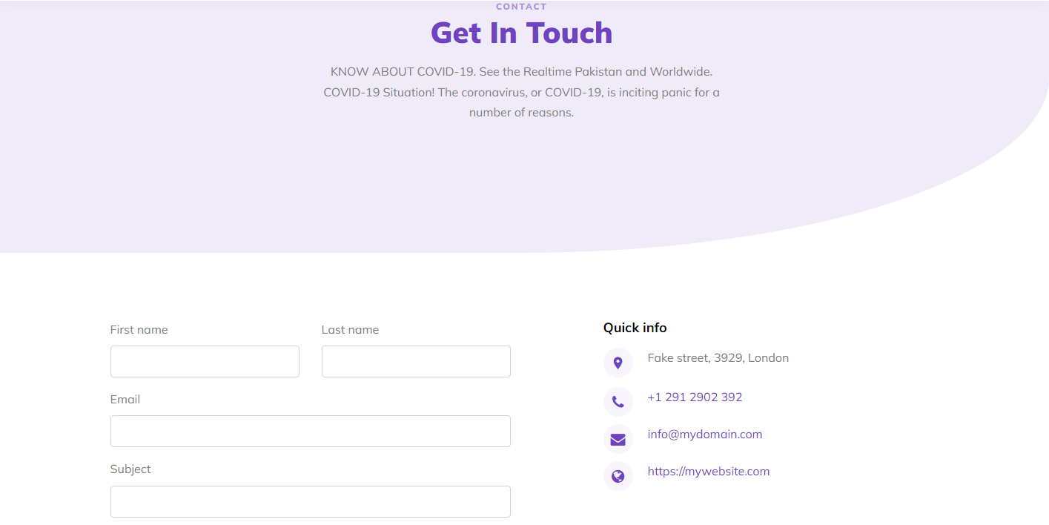



***Figure 8: Contact Us***

***9. Available Vaccine(vaccine.php)***

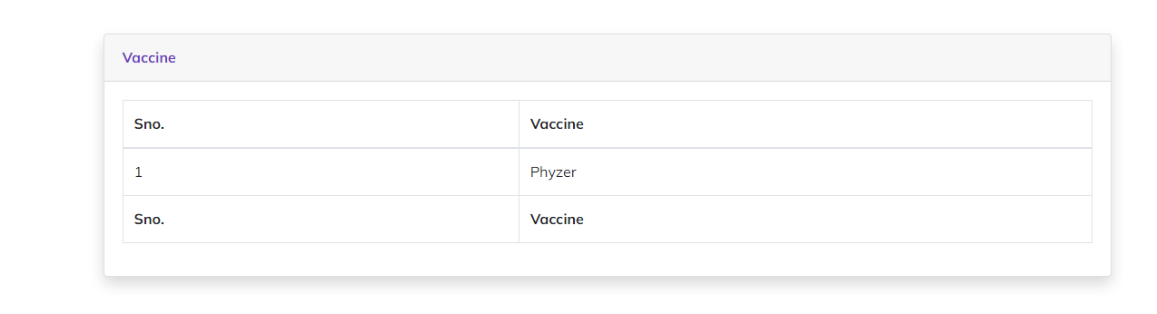

*Figure9:AvailableVaccines*

1. ***Available Hospital(hospital.php):***

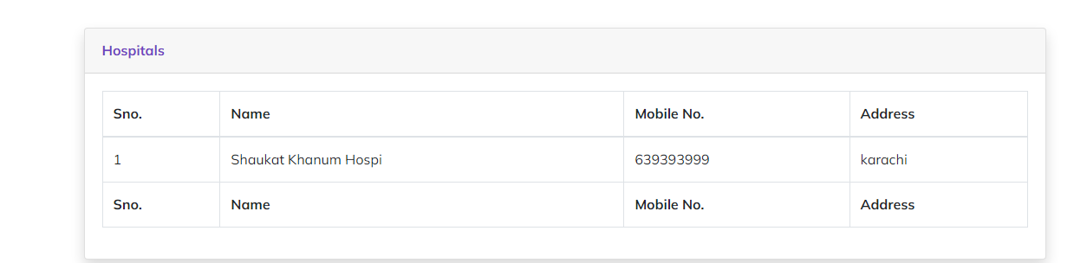

*Figure 10: Available Hospital:*

1. ***Book Vaccination Appointment(vaccination.php):***

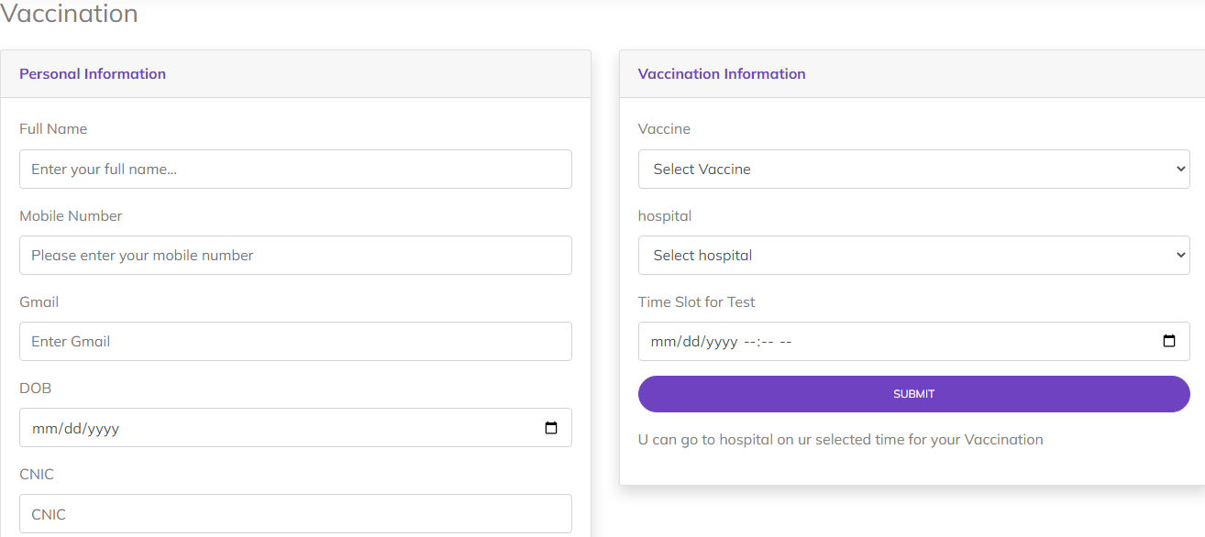

*Figure 11: Book Vaccine Appointment*

1. ***Footer(footer.php):***

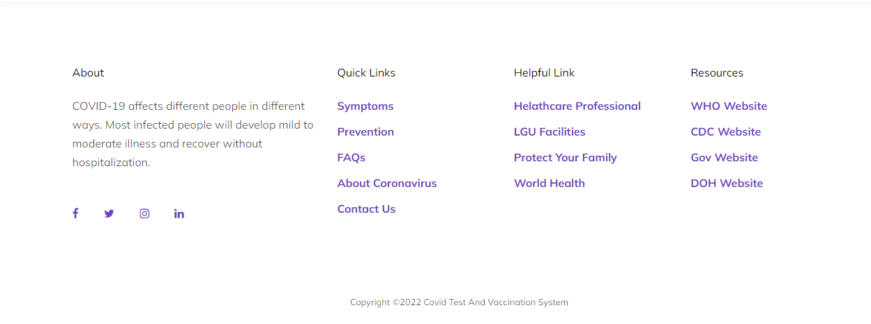

*Figure 12: Footer*

1. ***Menu bar:***

***Use to load the remaining sections. The following is a list of those sections:***

*As we have work on only single page and re-directing on other sections. So, we are made our web directed pages.*

1. **Patient Login (login.php):**
2. **Patient Signup (signup.php):**
3. **Home (index.php)**
4. **Navbar (header.php):**
5. **About us (about.php)**
6. **Covid Appointment (covidtest.php)**
7. ***Search Reports(covidresult.php)***
8. ***Contact Us(contact.php)***
9. ***Available Vaccine(vaccine.php)***
10. ***Available Hospital(hospital.php):***
11. ***Book Vaccination Appointment(vaccination.php):***
12. ***Footer(footer.php):***

***8.home (index (1).html):***

***BACKEND***

***Backend login page(adminlogin.php)***

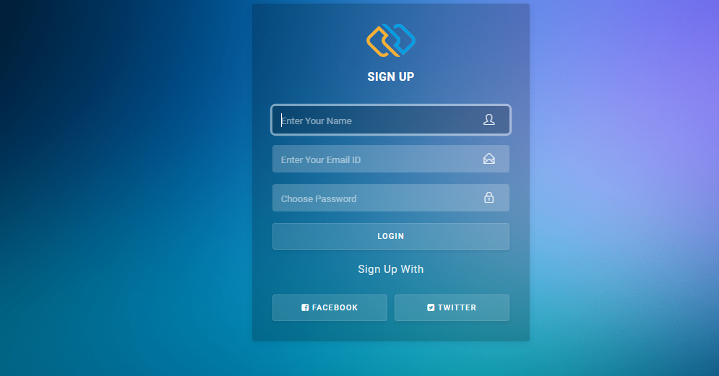

***Backend login page(hospitallogin.php)***

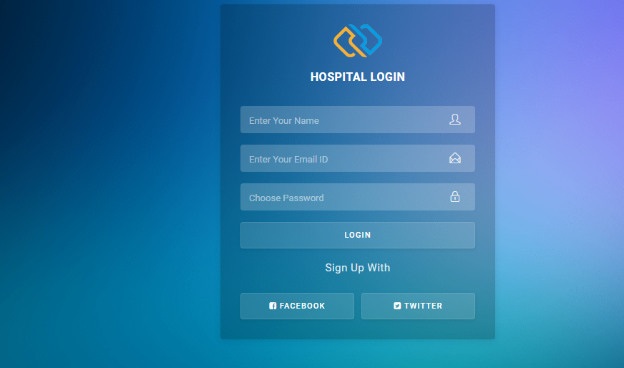

*Here you can login and login must required for enter the dashboard.*

***Dashboard (dashboard.php)***

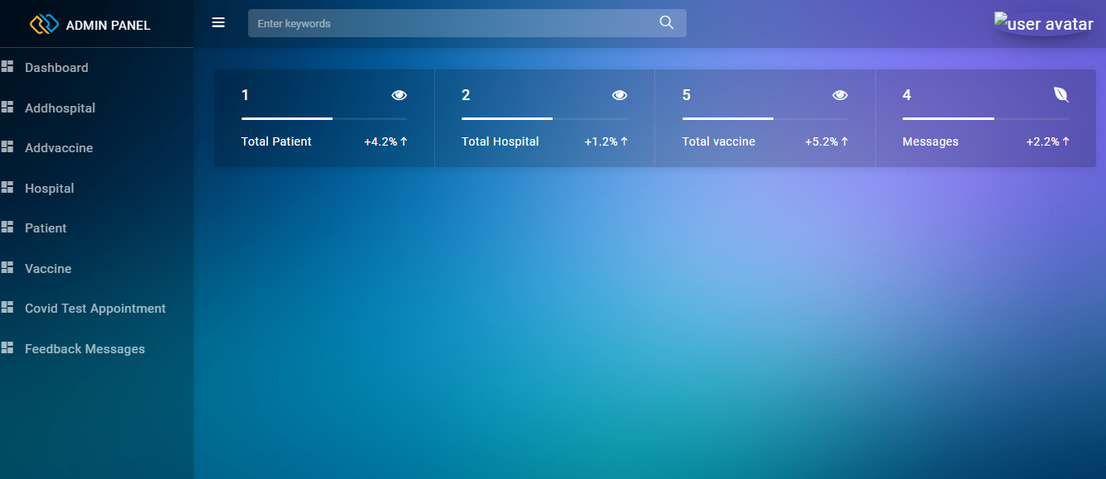

***Add hospital(addhospital.php)***

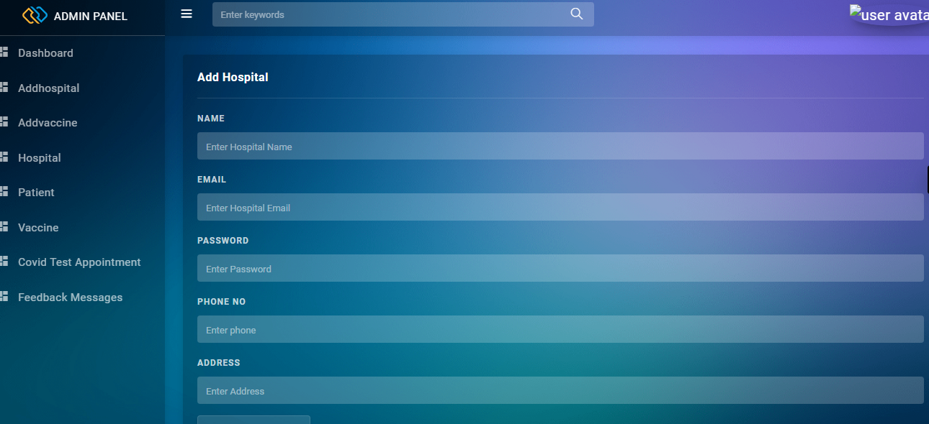

***Addvaccine(addvacine.php)***

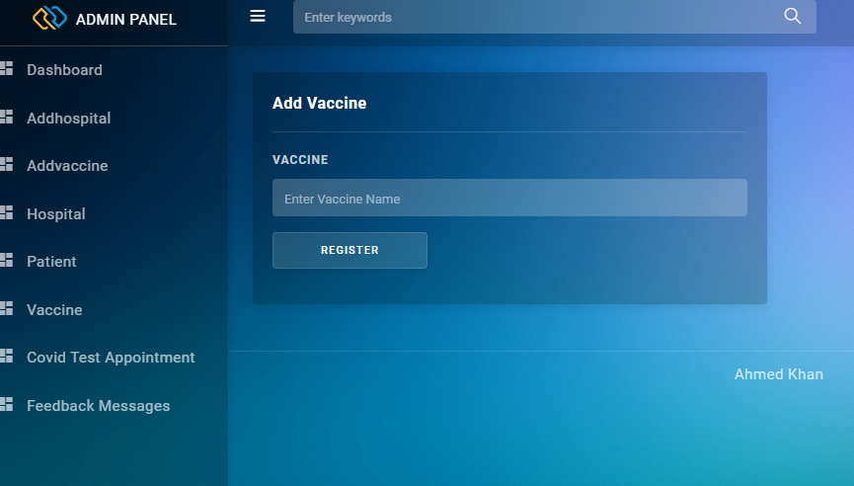

***Read hospital(Rhospital.php):***

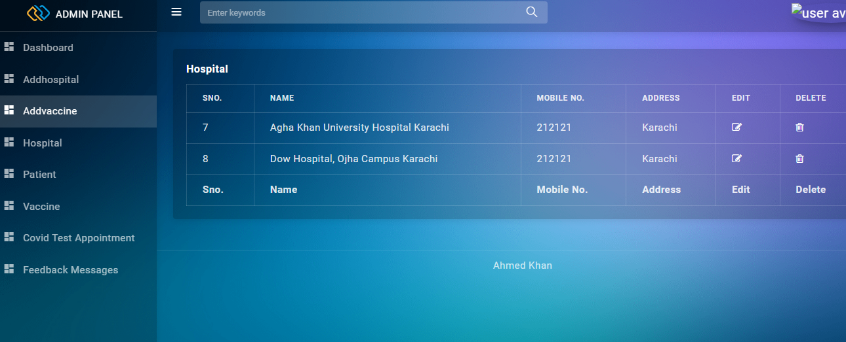

# Read Patient (RPATIENT.PHP)

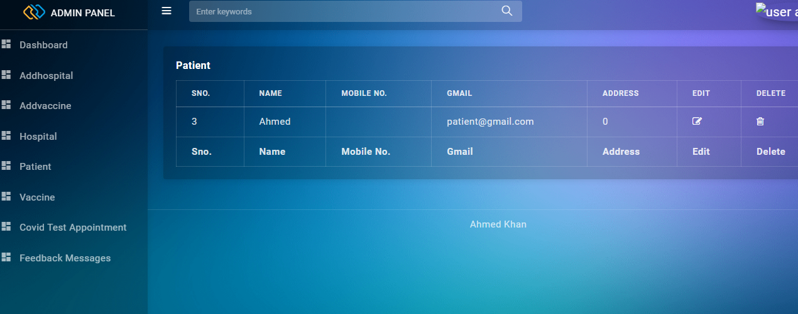

# READ VACINE (rEADvACINE.PHP)

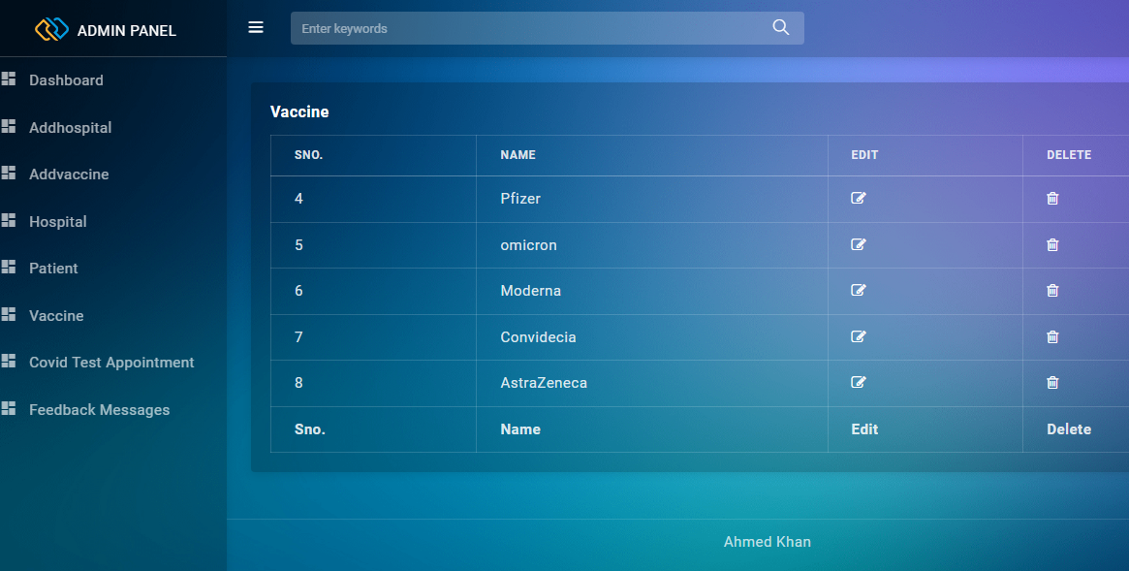

# COVID TEST APPOINTMENT(COVIDTEST.PHP)

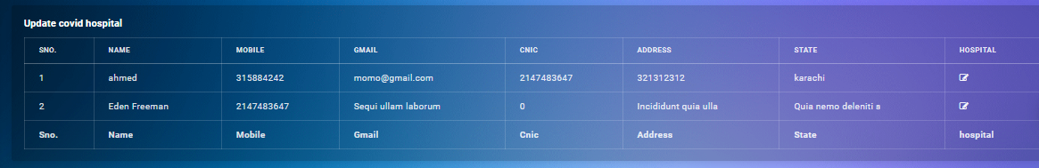

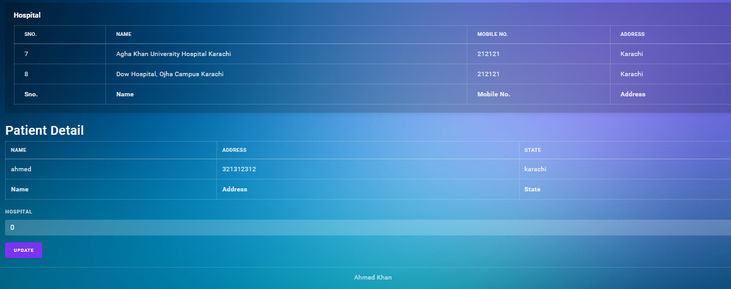

# feedback (feedback.php)

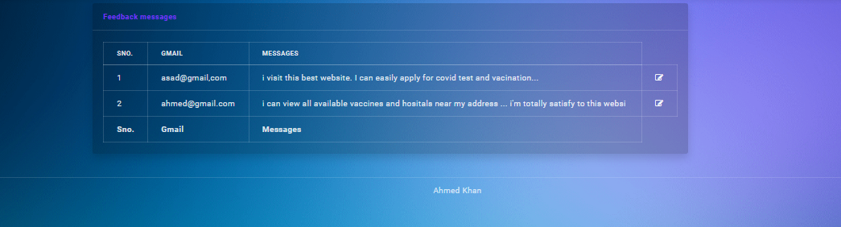

***Hospital panel***

***Hospitalprofile.php***

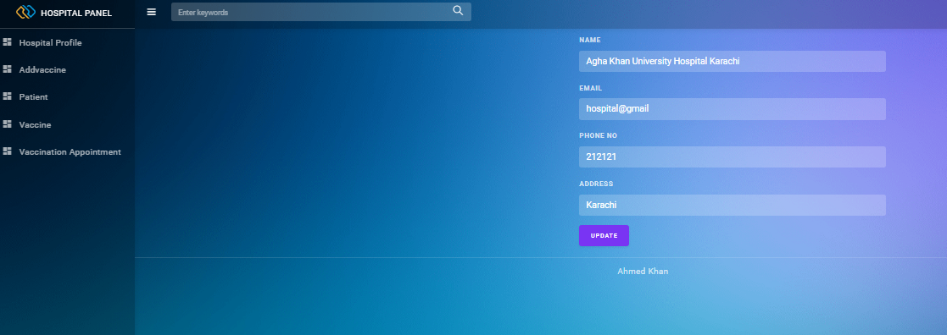

***Addvaccine(addvacine.php)***



# Read Patient (RPATIENT.PHP)



# READ VACINE (rEADvACINE.PHP)



**Vaccination appointment(Vaccinationapplication.php)**

